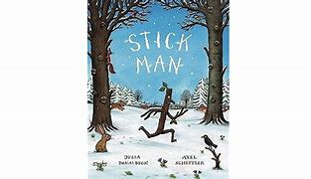

If you have the stick man book at home, have a read or watch the story using the link below:
Stickman | Books for Toddlers Read Aloud - YouTube

Make your own vision of the stick man story. What will your stick man look like? Create a story map. You could label your story with key words too.

Have some fun in the snow, do some mark making or writing in the snow?
What different words can you spell? Can you write your name?

