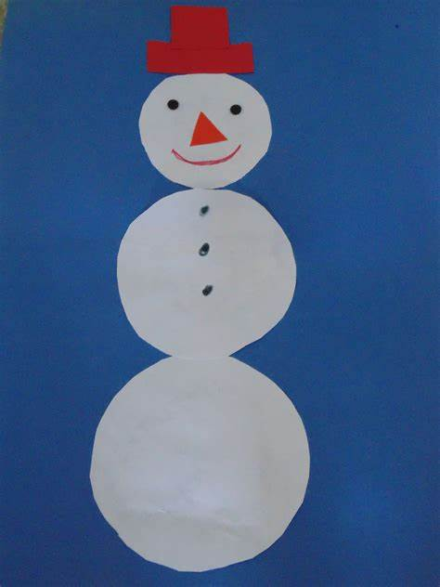

Build a snowman!

What different gross and fine motor skills did you use? Rolling balls big and small?

You could use the snowman you’ve made, create a paper snowman. Think about the different shapes you will use to create your snowman.

Could you label your snowman’s shapes and give him a name?

