Upper KS2 reading guide for parents

How to support your child with their reading

Why read at home?
Every parent has an important role to play in helping their child to read. A partnership between home and school is essential.
Research shows that daily reading has a huge impact on children’s development.
Even though your child will be reading fluently and independently most of the time, it is still essential to listen to children read aloud and ask probing questions to develop understanding. Pick out particularly challenging vocabulary and check understanding

How to Help – A Summary
Your child needs support to develop a range of strategies which support deep understanding of a text. The following are key areas your child needs support with.
1. Ways to support word reading
● Can they use a range of strategies? Recognising whole words/using their phonics to break words down/using the context of the sentence or clues in the pictures.
2. Reading Aloud
● Does your child use their voice to make their reading interesting?
● Can your child use expression?
● Does your child take into account sentence structure?
● Does your child respond to punctuation? For example looking for exclamation marks, speech marks, italics etc. to give clues.
3. Retrieval
● Can your child find information in the text to answer simple questions about who, where, when, what?
4. Interpretation
● Can your child put themselves in the character’s shoes?
● Answer questions such as: how do you think they feel? Why do you think/explain/how do we know? What might happen next? How is it set out? What type of text is it? (instruction/letter/newspaper/fairy story)
● If it is a non-fiction book, can your child explain how to use contents/index etc?
● Can your child discuss other stories they know with a similar setting or theme? How does this compare to other books by the same author?

5. Author’s choices and impact
● Can your child discuss the choices made by the author and the impact of these on the reader?
For example, answering questions such as: what words did the author use to create excitement or a sad feeling? Have they used similes or alliteration? Discuss adjectives or adverbs used and different types of sentences. How has the author set out or organised the text?

● Can your child identify purpose and viewpoint?
For example, answering questions such as: what effect does the text have on the reader? Is there an underlying message in the story/book e.g a battle between good and evil; pollution and green issues; being kind to each other? What do you think was the point of the text? Did the writer convince you that his or her ideas were right? Why/Why not?

Whilst children can appear to read confidently and fluently, they can still benefit from discussion and questioning around a text. You can find a document full of probing questions on our website. Being able to answer these types of questions will really deepen your child’s understanding.

5. Vocabulary within context
● Can fluently read unfamiliar or subject specific vocabulary within fiction and non-fiction texts?
● Do they understand the meaning of all the words? In some cases, especially with subject specific vocabulary you will need to tell them the meaning of new words but it is also important for your child to use their knowledge of the text so far, the understanding of the sentence and what is happening to work out the meaning of words. This is using the context of the text to help them. For example:
‘Johnathan was reluctant to ride his bike after he fell and broke his arm the previous year.’
Here they can use their contextual knowledge to work out the meaning of ‘reluctant’ by looking at the rest of the sentence. Encourage them to do this with words they are unfamiliar with, but could be worked out in context of the sentence/passage.

Reading your child’s school book with them
● If your child has read some of their book without you, can they summarise what they’ve read? Can they identify the key plot points they remember?
● Can your child answer simple retrieval questions about what they read independently? If not, perhaps they need to re-read this section.
● Listen to your child read a section of their book.
● Remember to sign your child’s reading record. Leave positive comments about their reading, for example ‘great reading tonight, you used great expression with the characters and remember to sound out longer, unfamiliar words’. This helps them to see what they need to focus on and gives additional information to their class teacher when planning support for your young reader.
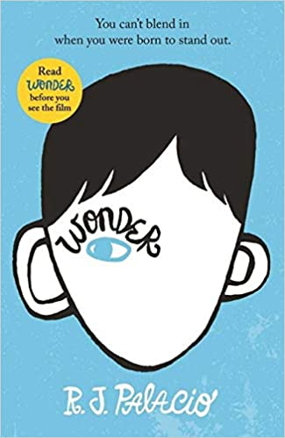

Additional Top Tips
● Model a love of reading to your child in a range of contexts. Show enthusiasm for reading and for books. You can also show a love for reading through story CDs and audiobooks. This gives them a broader range to access and enjoy reading.
● Keep tabs on the types of books your child is reading. Try to challenge them to read a range of text types.
● Use our recommended reading suggestions to help your child choose age appropriate, challenging books.
● Read aloud to your child texts they may not access on their own. Model higher level language choices and story structure through these challenging books.
Children are never too old to enjoy shared story time.

